ART, LIFE AND INFLUENCES OF JOHANNES VERMEER
AND HIS TIMELESS WORK EXPLORED ON WETA TV 26
- New Documentary on Dutch Master Coincides with Opening of Major Exhibit
of Vermeer and his Contemporaries
at The National Gallery of Art, Washington, Premieres October 6 —
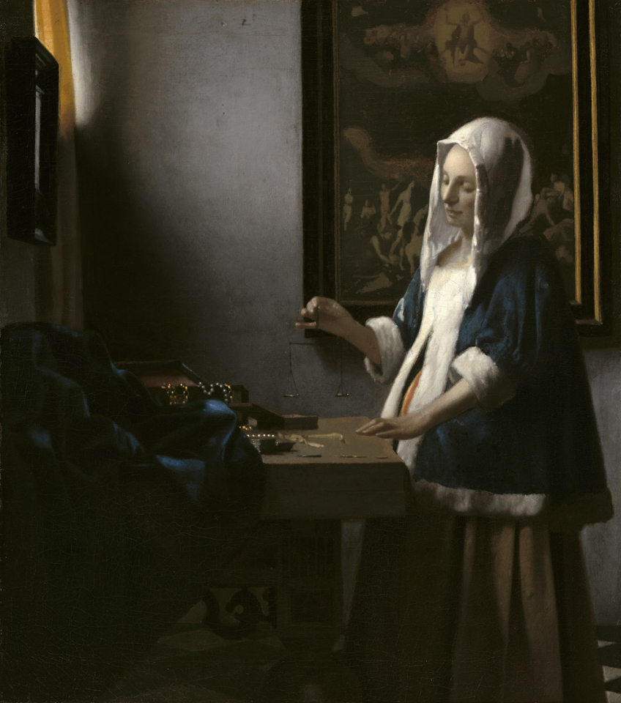

Woman Holding a Balance by Johannes Vermeer,
c. 1664, oil on canvas, Widener Collection 1942.9.97.
(Image Credit: Courtesy National Gallery of Art.)
WASHINGTON, D.C. — Johannes Vermeer, one of the most loved, treasured and well-known artists in the world today, is the subject of Vermeer, Beyond Time, a new feature documentary narrated by actor Steve Martin. French filmmaker Jean-Pierre Cottet adopts an imaginative and sensitive approach to his subject, examining how this painter from the small city of Delft, living and working in the Dutch Golden Age of the 17th Century, who died in penury and obscurity before being rediscovered some 200 years later, came to claim hearts and admiration throughout the world. The 90-minute documentary premieres Friday, October 6 at 9 p.m. ET on WETA TV 26, the flagship public broadcasting station in the nation’s capital. The film will be available to public broadcasting stations throughout the country in February 2018.

Images from Vermeer’s paintings have become instantly recognizable and part of the collective imagination. Focusing on the work itself and exploring Vermeer’s family life, the documentary traverses Vermeer’s conversion to Catholicism, his artistic contemporaries, and the wider world of the short-lived Dutch Republic. The documentary highlights the individual paintings — of which there are only 37 Vermeers in existence today, and imagines the narrow confines of the city of Delft and Vermeer’s particular corner of it, using digital techniques sparingly as well as dramatic enactments to conjure up a moving and affecting portrait of this unique genius.

“I am delighted our national capital audience can enjoy this timely special on Vermeer,” said Sharon Percy Rockefeller, president and CEO of WETA. “This film is a testament to our mission of providing programs of cultural merit.”

The Greater Washington premiere on WETA TV 26 of Vermeer, Beyond Time coincides with the opening of a major exhibit of Vermeer and his contemporaries at the National Gallery of Art, Washington on October 22, 2017. The National Gallery of Ireland; The Musée du Louvre, Paris; and the National Gallery of Art, Washington are the three venues for ‘Vermeer and the Masters of Genre Painting: Inspiration and Rivalry.’ This landmark exhibition examines the artistic exchanges among Johannes Vermeer and his contemporaries from 1650 to 1675, when they reached the height of their technical ability and mastery of depictions of domestic life. The exhibition brings together some 65 works by Vermeer (1632–1675) and his fellow painters of the Dutch Golden Age including Gerard ter Borch, Gerrit Dou, Pieter de Hooch, Gabriel Metsu, Frans van Mieris, Caspar Netscher and Jan Steen. Juxtaposing paintings related in theme, composition and technique, the exhibition explores how these artists inspired, rivalled, surpassed and pushed each other to greater artistic achievement. The exhibition features 10 paintings by Vermeer — many of which have not been seen in the United States since the Gallery’s 1995–1996 exhibition ‘Johannes Vermeer,’ including The Lacemaker (c. 1669–1670, Musée du Louvre, Paris). This exhibition is curated by Arthur K. Wheelock Jr., curator of northern baroque paintings, National Gallery of Art, Washington; Adriaan Waiboer, head of Collections and Research, National Gallery of Ireland, Dublin; and Blaise Ducos, curator of Dutch and Flemish paintings, Musée du Louvre, Paris. ‘Vermeer and the Masters of Genre Painting: Inspiration and Rivalry’ will be at the National Gallery of Art, Washington October 22, 2017–January 21, 2018. It enjoyed a critically-acclaimed and popular reception at the Musée du Louvre, Paris, February 20–May 22, 2017, where it was seen by over 300,000 visitors, and is at the National Gallery of Ireland, Dublin, June 17–September 17, 2017.

In a time when painters could expect to paint hundreds of works during their lifetime, Vermeer painted few canvases and had few clients. Vermeer, Beyond Time attempts to answer why he elected to paint so few pictures, and why he chose genre painting, focusing on scenes of daily life, rather than the more status-laden history paintings with their mythological and biblical scenes. Vermeer also always managed space in his works so as to create a barrier between picture and viewer, suspending time. The sense of intrigue and mystery about Vermeer’s work exists not just because there are so few paintings, but also because there are no writings and no drawings. There are no records of a master who might have taught him and no detail about himself as pupil. The documentary ascribes a flesh and blood character to this most elusive of artists.

Following Vermeer’s death in 1675 at the age of 43, his paintings were sold to cover his debts and Vermeer disappeared from memory. The rediscovery of his works some 200 years later has seen his popularity soar, claiming both hearts and admiration. In Vermeer, Beyond Time, Cottet explores the individual paintings, teasing out what has come to be known as the Vermeer style: the representation of light, the interplay of color and the effects of perspective across the same themes, places and objects. Vermeer, Beyond Time adds much to the understanding and knowledge of the painter, while still allowing for the mystery and allure of his art.

An electronic press kit for Vermeer, Beyond Time, including downloadable photos for promotional use, is available at weta.org/press.

Vermeer, Beyond Time is a production of Martange Production and Soho Moon Pictures for ARTE, RTÉ and WETA. The directors are Jean-Pierre Cottet and Guillaume Cottet. The producers are James Mitchell and Nathalie Cottet. The narrator is Steve Martin. The writer is Jean-Pierre Cottet. The editor is Sylvain Dlugokecki. The composers are Loran Delforge and Benjamin Ribolet. The director of photography is Patrice Caillonneau. The U.S. broadcast is made possible by The Rice Family Foundation. Vermeer, Beyond Time is a production in association with the National Gallery of Ireland; The Louvre, Paris; and The National Gallery of Art, Washington — the three venues for a major exhibition ‘Vermeer and the Masters of Genre Painting: Inspiration and Rivalry.’

# # #

About WETA Washington, D.C.
WETA Washington, D.C., is one of the largest-producing stations of new content for public television in the United States. WETA productions and co-productions include PBS NewsHour, Washington Week, The Kennedy Center Mark Twain Prize, The Library of Congress Gershwin Prize for Popular Song, documentaries by filmmaker Ken Burns and scholar Henry Louis Gates, Jr., and documentaries such as James McNeill Whistler & The Case for Beauty, Cézanne in Provence, Van Gogh’s Van Goghs, John Singer Sargent: Outside the Frame and Mary Cassatt: A Brush with Independence. The WETA studios and administrative offices are located in Arlington, Virginia. Sharon Percy Rockefeller is president and CEO of WETA. More information on WETA and its programs and services is available at weta.org. On social media, visit facebook.com/wetatvfm on Facebook or follow @WETAtvfm on Twitter.

