PBS Announces KEN BURNS PRESENTS
THE GENE: AN INTIMATE HISTORY,
New Collaboration with Siddhartha Mukherjee, M.D.
Three-Hour Documentary to Premiere Spring 2020 on PBS

– Barak Goodman to Produce Major Series
Inspired by Mukherjee’s Award-Winning Book –

– WETA Washington, D.C., Will Convene Partners to Create a National Engagement Campaign, Including Online Initiatives
and Public Screenings Across the U.S. –

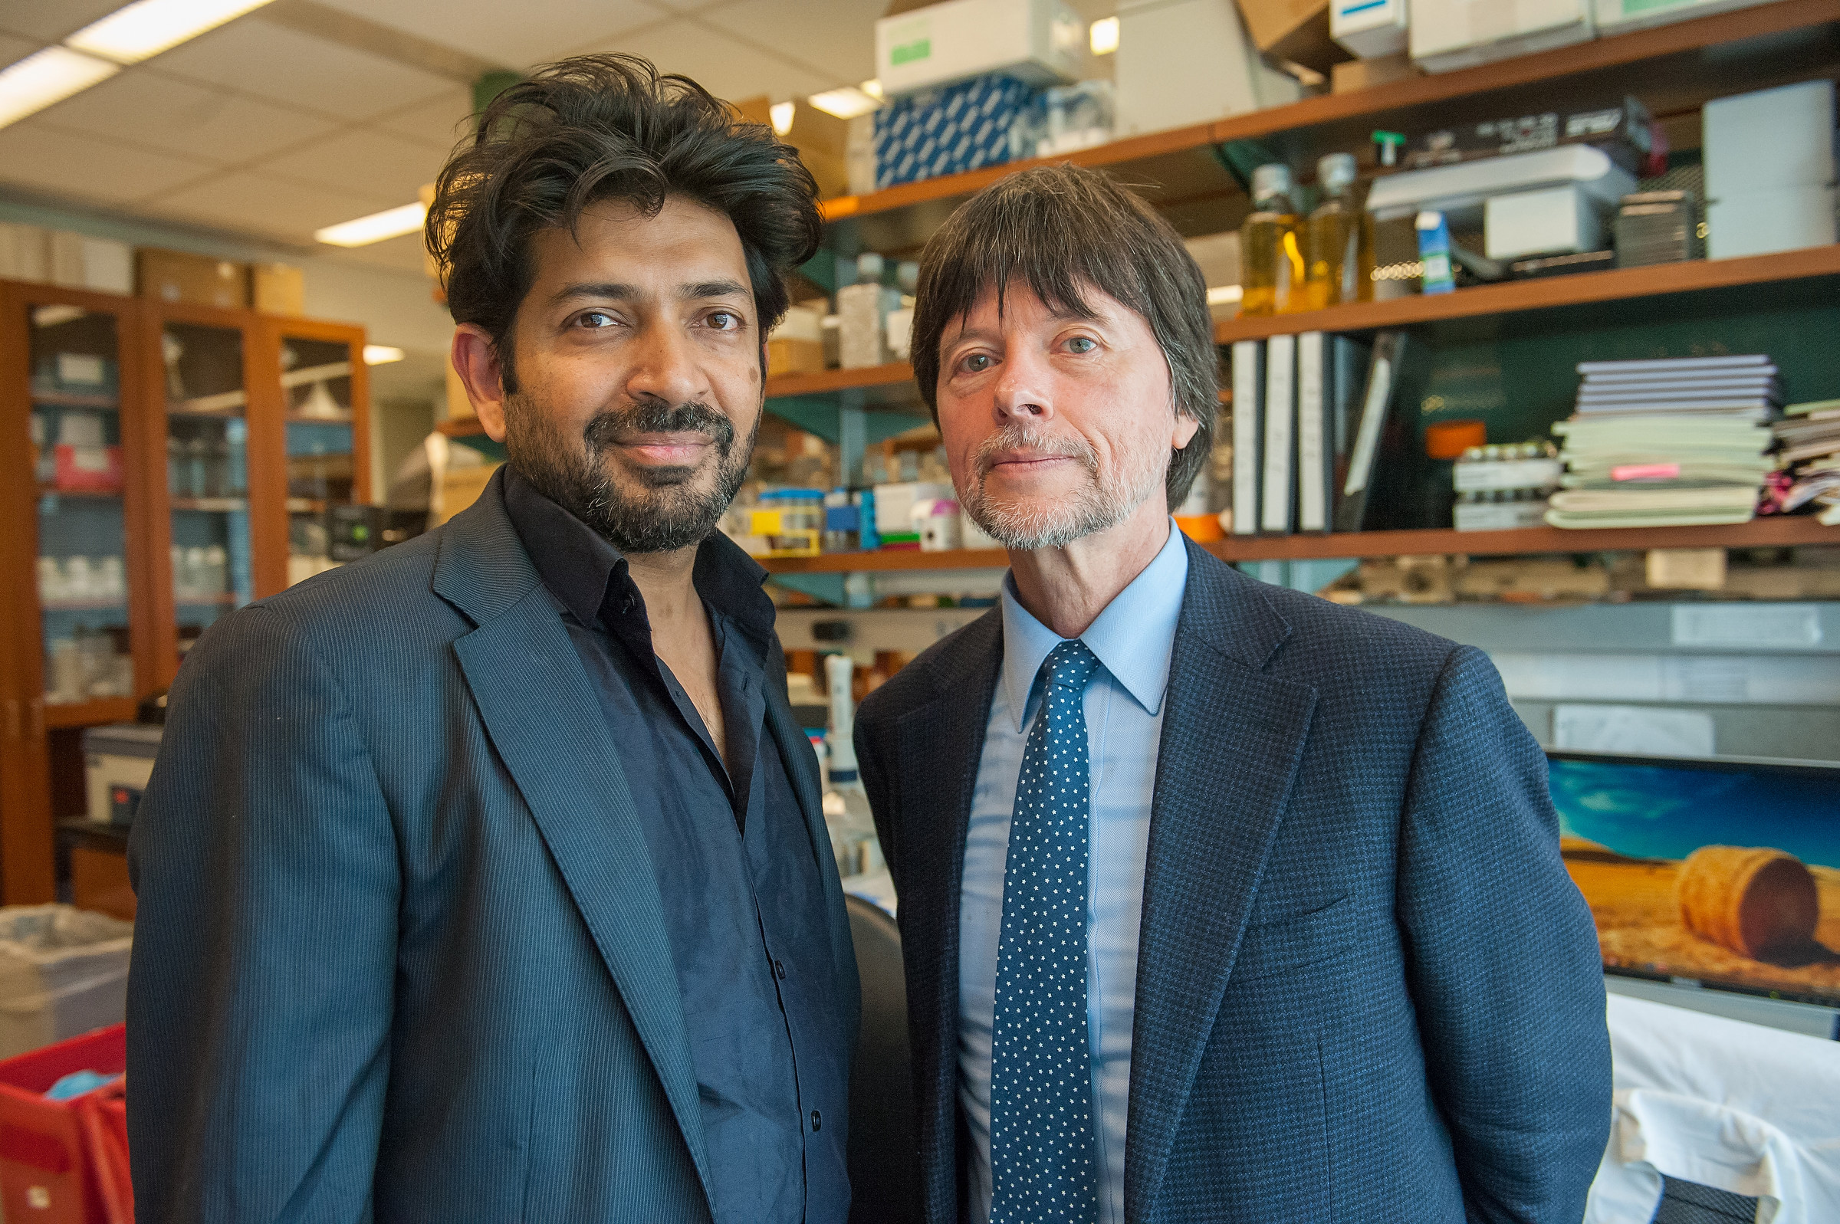
Siddhartha Mukherjee, M.D. and Ken Burns, Executive Producers of KEN BURNS PRESENTS THE GENE:
AN INTIMATE HISTORY
Credit: ©Stephanie Berger.
BEVERLY HILLS, CA; July 30, 2018 — Today at the Television Critics Association Press Tour, PBS announced Ken Burns Presents The Gene: An Intimate History, a new three-hour documentary executive produced by Ken Burns, will premiere over three nights in Spring 2020 on PBS. Pulitzer Prize-winning author Siddhartha Mukherjee, M.D., and acclaimed filmmaker Ken Burns will collaborate on the new documentary inspired by Mukherjee’s best-selling 2016 book, The Gene: An Intimate History. Award-winning filmmaker Barak Goodman will produce and, in addition to Burns and Goodman, the film will largely have the same production team behind the Emmy Award-nominated CANCER: THE EMPEROR OF ALL MALADIES, an adaption of Mukherjee’s earlier 2010 book that aired in 2015 on PBS.

“Science for me, like history, is the exploration of what has come before and the promise of the future,” said Ken Burns. “Working with Sid and Barak and the larger team on the CANCER film was an extraordinary opportunity to learn about the science behind cancer and the history of so many individuals and generations who have devoted their lives to fighting the disease, leading to today’s amazing breakthroughs. THE GENE will allow us to untangle what is in some ways a more complicated story, the code of life itself, and see how that understanding is being applied to science and medicine today.”

“It is truly an honor to be involved in this historic production,” said Mukherjee, assistant professor of medicine at the Department of Medicine (Oncology), Columbia University and staff cancer physician at Columbia University Medical Center. “Genes influence our forms and our fates, our behaviors and choices, and the forms, fates, behaviors and choices of every living being. We are living in an era when humans are beginning to read and write this ‘code of codes’ — our own code — with astonishing and unprecedented facility. Drawing elements from history, science, anthropology, ethics and medicine, this Ken Burns production will demonstrate how our understanding of genetics has evolved over the decades, and how deeply our future will be impacted by it. From the birth of genetics in the pea-garden of a modest monastery in Central Europe to the sweeping excesses of eugenics in Germany and the United States, from the stories of scientists who first discovered the structure of DNA to the recent attempts to change the genetic material of human embryos, from the identification of the first genes that cause human illnesses such as cancer and Cystic Fibrosis to the landmark experiments that led to the mapping of the human genome, this film will bring an immensely powerful and impactful science — and its enormous influence on culture — to life on the screen.”

WETA, a co-producer of the film and the leading public broadcasting station in the nation’s capital, originally announced in October 2016 that the public broadcaster had secured the rights to develop The Gene: An Intimate History into a documentary series executive produced by Ken Burns. Burns and Mukherjee were originally brought together by WETA President and CEO Sharon Percy Rockefeller in late 2010, soon after she read Mukherjee’s book The Emperor of All Maladies: A Biography of Cancer during treatment for cancer at the Sidney Kimmel Comprehensive Cancer Center at The Johns Hopkins Hospital in Baltimore.

“I am delighted WETA continues the collaboration with Ken and Sid,” said Rockefeller. “Just as CANCER: THE EMPEROR OF ALL MALADIES opened up a meaningful dialogue between patients, doctors and researchers, we believe that bringing THE GENE to television will be a groundbreaking opportunity to broaden public understanding of this fascinating and important subject.”

Now in active production, Ken Burns Presents The Gene: An Intimate History, much like the book, will use science, social history and personal stories to weave together a historical biography of the human genome while also exploring the stunning breakthroughs in understanding the impact genes play on heredity, disease and behavior. From the story of the remarkable achievements of the earliest gene hunters and the bitterly fought race to read the entire human genome, to the unparalleled ethical challenges of gene editing, the documentary will journey through key genetics discoveries that are some of the greatest achievements in the history of science.

“PBS and local stations have a legacy of raising awareness of medical science through in-depth documentaries,” said Paula A. Kerger, PBS President and CEO. “We expect this film to break new ground and spur dialogue, much the same way we did with CANCER: THE EMPEROR OF ALL MALADIES.”

“We are very pleased to support this important work from Ken Burns as part of our commitment to serving the America people through content and engagement that has the power to inform us on health issues and make a difference in our lives,” said Patricia Harrison, President and CEO of the Corporation for Public Broadcasting.

WETA has assembled an advisory committee of leading scientists and National Academy of Sciences (NAS) members for THE GENE that will work with the filmmakers to offer expert analysis of the film’s scientific content. Committee members include Nobel Prize winners Dr. David Baltimore, president emeritus, Robert Andrews Millikan professor of biology, Caltech; Dr. Elizabeth Blackburn, President Emerita, Salk Institute; Dr. Phillip Sharp, professor, MIT/David H. Koch Institute for Integrative Cancer Research; and Dr. Harold Varmus, former director, National Institutes of Health and National Cancer Institute. In addition, the advisory board includes R. Alta Charo, University of Wisconsin/co-chair of the new National Academy of Sciences Human Gene Editing Advisory Group; Dr. Francis Collins, director, National Institutes of Health; Sir Michael Stratton, director, Wellcome Trust Sanger Institute and chief executive officer, Wellcome Genome Campus; Dr. Eric Topol, director, Scripps Translational Science Institute; and Dr. Huda Zoghbi, professor, Baylor College of Medicine and Texas Children’s Hospital.

Mukherjee will serve as a consultant, creative advisor and executive producer to the production. His book upon which the documentary is based reached #1 on the New York Times bestseller list and received wide critical acclaim. Anthony Doerr, author of All the Light We Cannot See, wrote, “This is perhaps the greatest detective story ever told — a millennia-long search, led by a thousand explorers, from Aristotle to Mendel to Francis Collins, for the question marks at the center of every living cell. Like The Emperor of All Maladies, The Gene is prodigious, sweeping, and ultimately transcendent. If you’re interested in what it means to be human, today and in the tomorrows to come, you must read this book.”

Integral to the project will be an extensive engagement program that will be created by WETA, in collaboration with an array of partners, in particular the National Institute of Health’s National Human Genome Research Institute (NHGRI). Production and outreach funders Genentech, a member of the Roche Group; the National Human Genome Research Institute at the National Institutes of Health; 23andMe; American Society of Clinical Oncology (ASCO) and its Conquer Cancer Foundation; Basser Initiative at Gray Foundation; Cancer Treatment Centers of America; Foundation Medicine, Inc.; Craig and Susan McCaw Foundation; and major funder the Corporation for Public Broadcasting will support project initiatives to expand the reach of the series. The involvement of these partners will enable the film to reach an even larger audience, engaging researchers, physicians and patients in the national conversation about the topic. In the months building up to the national broadcast premiere, the group will organize screenings and discussions in cities across the country, working with local public television stations and a wide range of educational, medical and scientific organizations.

In conjunction with the broadcast, WETA will also develop a robust interactive website and social and digital media components, including a multi-media educational initiative designed to engage teachers and students through multiple platforms.

Ken Burns Presents THE GENE: AN INTIMATE HISTORY is a production of Florentine Films and WETA Washington, D.C., in association with Ark Media. Executive Producer and Senior Creative Consultant: Ken Burns. Written by Geoffrey Ward and Kenneth L. Burns; and Barak Goodman and David Blistein. Based on the book The Gene: An Intimate History by Dr. Siddhartha Mukherjee. Produced by Barak Goodman. Executive Producers: Dr. Siddhartha Mukherjee, Dalton Delan, Tom Chiodo and Anne Harrington. Production and outreach funding has been provided by Genentech, a member of the Roche Group; the National Human Genome Research Institute at the National Institutes of Health; 23andMe; American Society of Clinical Oncology (ASCO) and its Conquer Cancer Foundation; Basser Initiative at Gray Foundation; Cancer Treatment Centers of America; Foundation Medicine, Inc.; and Craig and Susan McCaw Foundation. Major funding has also been provided by the Corporation for Public Broadcasting.

– PBS –

WETA Washington, D.C., is one of the largest producing stations of new content for public television in the United States. WETA productions and co-productions include PBS NewsHour, Washington Week, The Kennedy Center Mark Twain Prize, THE LIBRARY OF CONGRESS GERSHWIN PRIZE FOR POPULAR SONG, Latino Americans, The Italian Americans and documentaries by filmmaker Ken Burns, including Ken Burns Presents CANCER: THE EMPEROR OF ALL MALADIES A Film by Barak Goodman, and films by scholar Henry Louis Gates, Jr. Sharon Percy Rockefeller is president and CEO. More information on WETA and its programs and services is available at www.weta.org.

Ark Media was founded by Barak Goodman and Rachel Dretzin in 1996, and they were joined by partner John Maggio in 2003. Together, Goodman, Dretzin, and Maggio have grown Ark into a leading producer of non-fiction series, theatrical documentaries, and television specials on a wide variety of subjects, along the way nurturing a diverse roster of passionate and talented filmmakers. Ark’s films have been honored with four national primetime Emmy Awards, an Academy Award nomination, multiple Writers Guild Awards, two duPont Columbia batons and three George H. Foster Peabody Awards, among many other awards and accolades. Coming soon: the feature documentary adaptation of Andrew Solomon’s monumental nonfiction book, Far From the Tree, in partnership with Participant Media; an American Experience film about Teddy Roosevelt’s fateful journey down an unknown Amazonian river in 1914, which almost cost him his life; a film for MSNBC about the press during the civil rights era; and a four-part series about genetics, based on Siddhartha Mukherjee’s best-seller The Gene: An Intimate History.

About PBS
PBS, with nearly 350 member stations, offers all Americans the opportunity to explore new ideas and new worlds through television and digital content. Each month, PBS reaches over 90 million people through television and 30 million people online, inviting them to experience the worlds of science, history, nature and public affairs; to hear diverse viewpoints; and to take front row seats to world-class drama and performances. PBS’ broad array of programs has been consistently honored by the industry’s most coveted award competitions. Teachers of children from pre-K through 12th grade turn to PBS for digital content and services that help bring classroom lessons to life. Decades of research confirms that PBS’ premier children’s media service, PBS KIDS, helps children build critical literacy, math and social-emotional skills, enabling them to find success in school and life. Delivered through member stations, PBS KIDS offers high-quality educational content on TV – including a 24/7 channel, online at pbskids.org, via an array of mobile apps and in communities across America. More information about PBS is available at www.pbs.org, one of the leading dot-org websites on the internet, or by following PBS on Twitter, Facebook or through our apps for mobile and connected devices. Specific program information and updates for press are available at pbs.org/pressroom or by following PBS Pressroom on Twitter.

The Corporation for Public Broadcasting (CPB), a private, nonprofit corporation created by Congress in 1967, is the steward of the federal government’s investment in public broadcasting. It helps support the operations of more than 1,500 locally owned and operated public television and radio stations nationwide. CPB is also the largest single source of funding for research, technology, and program development for public radio, television and related online services. More information about CPB is available at www.cpb.org.

Press Contact
DKC Public Relations
Brian Moriarty, brian_moriarty@dkcnews.com / 212.981.5252

